**BASIC CASE STUDY**

**COMPUTER NETWORKS BASIC COMMANDS PRACTICSE IN CMD MODE**

**Netstat** — derived from the words network and statistics — is a program that’s controlled via commands issued in the command line. It delivers basic statistics on all network activities and informs users on which portsand addresses the corresponding connections (TCP, UDP) are running and which ports are open for tasks.

|  |  |
| --- | --- |
| netstat | Standard listing of all active connections |
| -a | netstat -a | Displays all active ports |
| -b | netstat -b | Displays the executable file of a connection or listening port (requires administrator rights) |
| -e | netstat -e | Shows statistics about your network connection (received and sent data packets, etc.) |
| -f | netstat -f | Displays the fully qualified domain name (FQDN) of remote addresses |
| -i | netstat -i | Brings up the netstat overview menu |
| -n | netstat -n | Numerical display of addresses and port numbers |
| -o | netstat -o | Displays the process identifier (PID) associated with each displayed connection |
| -p Protokoll | netstat -p TCP | Displays the connections for the specified protocol, in this case TCP  (also possible: UDP, TCPv6, or UDPv6) |
| -q | netstat -q | Lists all connections, all listening TCP ports, and all open TCP ports that are not listening |
| -r | netstat -r | Displays the IP routing table |
| -s | netstat -s | Retrieves statistics about the important network protocols such as TCP, IP, or UDP |
| -t | netstat -t | Shows the download status (TCP download to relieve the main processor) of active connections |
| -x | netstat -x | Informs about all connections, listeners, and shared endpoints for NetworkDirect |
| -y | netstat -y | Displays which connection templates were used for the active TCP connections |
| Interval | netstat -p 10 | Displays the respective statistics again after a selected number of seconds (here 10); can be combined as required (here with –p), [CTRL] + [C] ends the interval display |

List of all connections for the IPv4 protocol

If you don't want to retrieve all active connections, but only all active IPv4 connections, you can do this using the netstat command

**netstat -p IP**

Accessing statistics using the ICMPv6 protocol

**netstat -s -p icmpv6**

Display of all open ports and active connections (numeric and process ID included)

**netstat -ano**

Tracert: Determines the path taken to a destination by sending Internet Control Message Protocol (ICMP) Echo Request messages to the destination with incrementally increasing Time to Live (TTL) field values. The path displayed is the list of near-side router interfaces of the routers in the path between a source host and a destination

tracert www.google.co.in

**Arp**

Displays and modifies entries in the Address Resolution Protocol (ARP) cache, which contains one or more tables that are used to store IP addresses and their resolved Ethernet or Token Ring physical addresses. There is a separate table for each Ethernet or Token Ring network adapter installed on your computer.

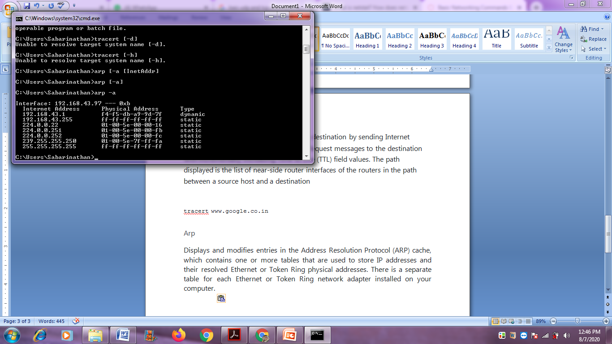

Arp –a [in command prompt]

**arp [-a [InetAddr]**

**[-N IfaceAddr]]**

**[-g [InetAddr]**

**[-N IfaceAddr]]**

**[-d InetAddr [IfaceAddr]]**

**[-s InetAddr EtherAddr [IfaceAddr]]**